National Summit for Educational Equity Proposal

Due- November 30, 2018

Presenter/s Information
Tonette Salter - Ca Perkins Joint Special Populations Advisory Committee
900 Rancho San Diego Parkway, El Cajon, CA 92019
tonette.salter@gcccd.edu
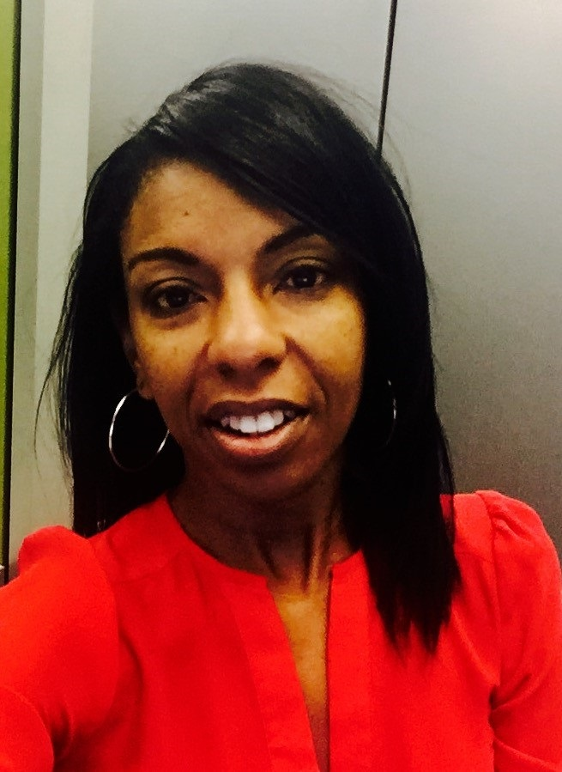
Tonette Salter is an Organizational Developer at heart. Her practice is to lead systemic change in the beliefs, attitudes, and values of people for individuals, and organizations for community prosperity. She has built her career over the past 16 years in development and implementation of restricted funding (Grants) for Career Education/Career Technical Education Programs with emphasis on underrepresented students for the Foundation of Grossmont-Cuyamaca Colleges’ Auxiliary Organization (FGCCD). Her expertise lies in strategic planning initiatives, budget administration, grant writing and grant implementation, program development and implementation, relationship building, and maintaining to improve equity for students, educators, and organizations. Her current role is the coordinator of the California Perkins Joint Special Populations Advisory (JSPAC). JSPAC is a joint effort of the California Department of Education (CDE) and California Community Colleges Chancellor’s Office (CCCCO) to improve equity and access for underrepresented/special population students to career pathways leading to high wage occupations.
Tonette’s passion for prosperity trickles into her personal life, she volunteers as the Chair of the Black American Political Association Chapter (BAPAC) San Diego, CA Disconnected Youth Committee, she is an advocate of Mental Health Illness and is a volunteer for National Alliance of Mental Health Illness (NAMI) as a job coach mentor, and she is a board member of the third oldest surviving African American Theatre organization in the country. She is a graduate of SDSU and has a MS in Psychology with an emphasis on research and human performance.

LinkedIn @ttonette-salter-ms-psychology
Twitter @#JSPAC4Equity

Alyssa Bahr Casillas, Ed.D. -California Community Colleges Chancellor's Office Statewide Collaborative for Special Special Populations
West Hills Community College District
alyssacasillas@whccd.edu

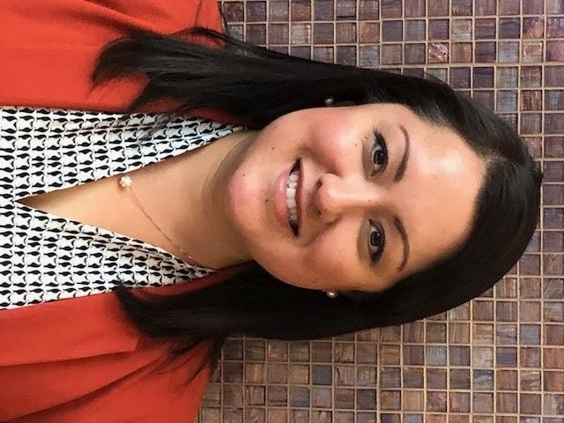

Alyssa Bahr Casillas, Ed.D. lives by the belief that we are all interconnected on a global scale. This notion is what espouses her work serving others. For the past 15 years, Dr. Bahr Casillas has passionately dedicated herself to education, with extensive experience in Student Services, Academics, Professional Development, Leadership, and International Development. She has served faculty, staff, students and communities in both the private and public sector in a variety of capacities, including Dean of Students and Dean of Instruction.

Dr. Bahr Casillas’ current work focuses on Special Populations in Career and Technical Education and Student Services.

Growing up in Modesto, she longed for expansion, so she made the move to the City, crossing the Bay Bridge (the old Bay Bridge at the time) into San Francisco. There she attended the University of San Francisco (USF), receiving a Bachelor’s of Art Degree in Politics, a Master’s of Education in Organization and Leadership, and an Educational Doctorate in Organization and Leadership. It was at USF, one the country’s most diverse, social justice, Jesuit institutions that her horizon expanded to include service in the developing world, participating in various ministry and social justice projects abroad. That calling continues to this day as she currently serves as a standing board member on a local, non-profit serving various people groups in South East Asia and Africa. She has since returned to the Central Valley where she resides with her husband and son.

Toni Brooks - President/CEO, Toni Brooks Foundation (501c3 nonprofit org / EIN# 83-1594462),
111 W 7th St STE 502, Los Angeles, CA, 90014,

Toni Brooks is a serial Entrepreneur and Philanthropist who has made helping others part of her professional and personal lifestyle and believes if we focus on just being a good person, good will come out of us.
Having spent nearly two decades designing business development strategy for small businesses and multi-million dollar corporations, Toni challenged her clients to realize their community development potential resulting in female veterans, domestic violence survivors and foster young adults being clothed in brand new apparel and the securement of countless employment opportunities through job readiness program.
As an awarded philanthropist receiving numerous accolades from various private organizations as well as the Los Angeles County, Toni serves as the President & CEO of the Toni Brooks Foundation, an organization that has clothed nearly 1200 transitioning women in over 83k in brand new clothing.

Toni is a graduate from Southern Illinois University Carbondale and holds a Bachelor of Science Degree in Business Management with specializations in Management Informations Systems and Entrepreneurship, a Bachelor of Science Degree in Marketing and has served in the Army National Guard.

Keep up with Toni at:
LinkedIn @tonibrooks
Instagram @thephashlife
Twitter @thephashlife

Title:
Entrepreneurship Necessity through a Female Veteran’s Lens: A Panel Discussion Featuring Toni Brooks of the Toni Brooks Foundation, Supported by data presented by the CA Joint Special Populations and the California Community College Statewide Collaborative.

Conference Strand - Building a diverse workforce

Type of Presentation - implementation/practice and outreach

Practical Application Focused Information
- Raising awareness there is a difference between ‘income’ and ‘career’ and realizing
financial and housing sustainability
- Community College Women Veterans Data
- Transition differences between women and men veterans
- Supporting Women Veterans with the Three A’s Affect, Affirmation, Aid

Populations Veterans or Military Personnel, Homeless Individuals, Single Parents, Older Workers, Out-of-Work Individuals, Foster Youth, Economically Disadvantaged, Adult Learners

Intended Audience: Educators, Business, Government, Military and Veterans, Workforce Development, Non-Profit Organizations

Abstract
All veterans returning home from long periods of service face a range of difficult challenges, from narrowing opportunities to trouble feeling a sense of belonging. Female veterans face everything their male counterparts do, compounded by the mere fact they are female. Women have been traditionally underrepresented and women veterans are often treated by society as invisible. The return to “normalcy” for female veterans involves a lengthy transition process, one that is rarely without soul-wrenching frustration and disappointment. There are critical hurdles a female veteran has to face: damaging stereotypes, a VA that was systematically created for men, a society that doesn’t understand female soldiers, and transition programs leading to career employment opportunities created for men. Join us in this heartfelt, honest, candid discussion with the CA Joint Special Populations and Statewide Collaborative for Special Populations as we zoom in on data about Women Veterans/Military and thinking differently. Let’s talk entrepreneurship necessity with a veteran owner, Toni Brooks of the Toni Brooks Foundation (TBF), and her veteran colleagues. Leave this session with insight on engaging and supporting Women Veterans to build a diverse workforce.

Full Description
All veterans returning home from long periods in service face a range of difficult challenges, from narrowing opportunities to trouble feeling a sense of belonging. Female veterans face everything their male counterparts do compound by the mere fact they are female. Women have been traditionally underrepresented and women veterans are often treated by society as invisible. There are almost 22 million veterans in the United States today, more than two million are women, and of those, over 635,000 are enrolled in the Department of Veterans Affairs system, double the number before 9/11. Many female veterans are returning home with PTSD — the No. 1 complaint among women seeking treatment at Veterans Affairs (VA) health facilities. Unfortunately, these veterans aren’t always getting the care they require from a system originally designed to serve primarily men. Quite often within the culture of VA women are made to feel unwelcome and invisible and face additional issues such as homelessness. In the 2017 Annual Homeless Assessment Report to Congress, the U.S. Department of Housing and Urban Development (HUD) estimated over 40,000 veterans were homeless on a single night in January of that year. Of those, about 9 percent were women (US Census, 2015). From 2016 to 2017, the number of homeless female veterans increased by 7 percent, compared with 1 percent for their male counterparts.
Additionally, some female veterans may be victims of military sexual trauma and feel resentment towards the military and the VA. Consequently, they do not identify themselves as being a veteran. These women veterans tend to stay away from the organizations wishing to help them because they feel they were betrayed by that organization in the past. Also, many women veterans don't seek help because they were instilled with a sense of self-reliance and pride while in the military.
The return to “normalcy” for female veterans involves a lengthy transition process, one that is rarely without soul-wrenching frustration and disappointment. There are critical hurdles a female veteran has to face: damaging stereotypes, a VA that was systematically created for men. Society doesn’t understand female soldiers, and transition programs leading to career employment opportunities were created primarily for men. While unemployment rates among veterans have generally been lower than those of the general population, young women veterans returning from Afghanistan and Iraq are unemployed and out of necessity are choosing entrepreneurship career opportunities.
Perhaps the biggest factor encouraging women veterans to start their own companies has been the unusually high unemployment rates. According to data from Syracuse University, the overall female veteran unemployment rate from 2008 to 2012 was 11.1 percent, compared with 7.1 percent for other women. Among young female veterans, the numbers were worse. In 2011, female veterans who were 20 to 24 years old had an unemployment rate of 35.4 percent. Looking at the data slightly differently, an unexpected trend is happening. Tere is a group of business owners who are solid and are women veterans-- women who have served in the armed forces and are now returning to civilian life to build businesses and jobs.

We already know that women business owners are driving the growth in small business, and that within that group, it is women of color who are making the most progress. Join us in this heartfelt, honest, candid discussion with the CA Joint Special Populations and Statewide Collaborative for Special Populations to zoom in on data about women veterans/military and thinking differently. Let’s talk entrepreneurship necessity with veteran owner, Toni Brooks of Toni Brooks Foundation (TBF), and her veteran colleagues.

Availability: Tuesday, April 30 or Thursday May 2, 2019
.
Source Source: U.S. Census Bureau, American Community Survey, 2015 Prepared by the National Center for Veterans Analysis and Statistics

