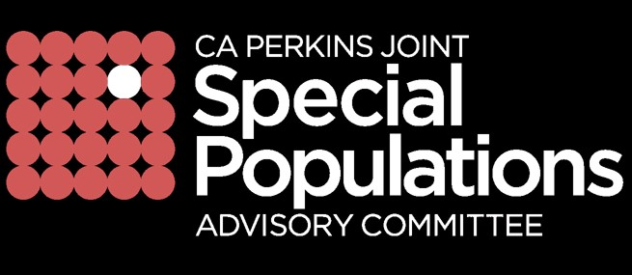

DRAFT- GENERAL MEETING of the Joint Special Populations Advisory Committee (JSPAC) MINUTES
Holiday Inn Capitol Plaza, Sacramento
November 30, 2018, 1:30 p.m. to 3:30 p.m.

PARTICIPANTS PRESENT:
K-12-Adult Representatives: Leslie Aaronson, Don Isbell, Elodia Lampkin, Katrina Leon, Susi Huschle, Kim Sakamoto
Community College Representatives: Rosie Antonecchia, Gustavo Chamorro, Roberta Kunkel, Carmen Lamha, Sheryl Plumley, Adam Runyan, Federico Saucedo
Public/Private Representatives: LaVonne Slaton
Staff: Tonette Salter
State Representative: Gary Page, Maureen White
Guest: Eric Mooney, Director Secondary Education, Colton Unified School District
Absent: Susan Bollenbach, Chris Boyton, Kristin Boroski, Marie Ganister, Abigale Medina, Andy Page, Susan Wheeler, LeeAnn McNulty

TOPIC | PRESENTER | DISCUSSION / ACTION
Call to Order/Member Welcome | Susi Huschle,  Co-Chair | The meeting was called to order at 1:33pm by Susi Huschle. A quorum was not established because there was not enough voting members present. Committee recommended to approve minutes online.
Membership | Susi Huschle,  Co-Chair | The announcement was made of vacancies  - K-Adult Education (2) (Region 2: Siskiyou, Modoc, Trinity, Shasta, Lassen, Tehama, Glenn Butte, Plumas) & (Region 6: San Joaquin, Amador Calveras, Tuolumne, Stanislaus)  - CC (3) (Region 2: Northern Inland), (Region 5: Central, & (Region 6: South Central)  - Private/Public Sector (7).  - Community College Co-Chair – Recommended to nominate Co-chair via online (Susi Huschle and Carmen Lamha) will lead the effort of recruitment
State Updates | Gary Page  CDE Representative  Maureen White  CCCCO Representative | - Government has asked CDE to develop a state plan to address workforce pathways. At the local level a group has been formed called the California Workforce to develop the plan based on the guiding policy principles. More information at https://www.cde.ca.gov/ci/ct/gi/guidingpps.asp  - Maureen will be meeting with Daisy Gonzales, Deputy Chancellor of Community Colleges on December 12, 2019 to discuss Perkins Leadership Title grants: CA Joint Special Populations Advisory Committee and Special Populations Collaborative efforts in equity and leveraging those efforts with other initiatives. JSPAC will provide a document for Maureen to use for discussion to include JSPAC focus on: regional equity professional development, expectations statewide, transition support between K-14 SWP and data, and integrated planning and that this is a joint effort between K-12, Adult Ed and Community Colleges.
Announcements/ Informational Items | Co-Chairs | Announcements/Informational Items  - JSPAC will be participating in the Student Equity Achievement workgroup for CCCCO to outline and align metrics and guidelines for the Vision for Success Initiative  - Humboldt County – Held a community Equity Summit in collaboration with Department of Human Health Services and Humboldt State University  - March 6, 2019 –Spring Meeting
Adjourned |  | The meeting was adjourned at 3:00 p.m.

